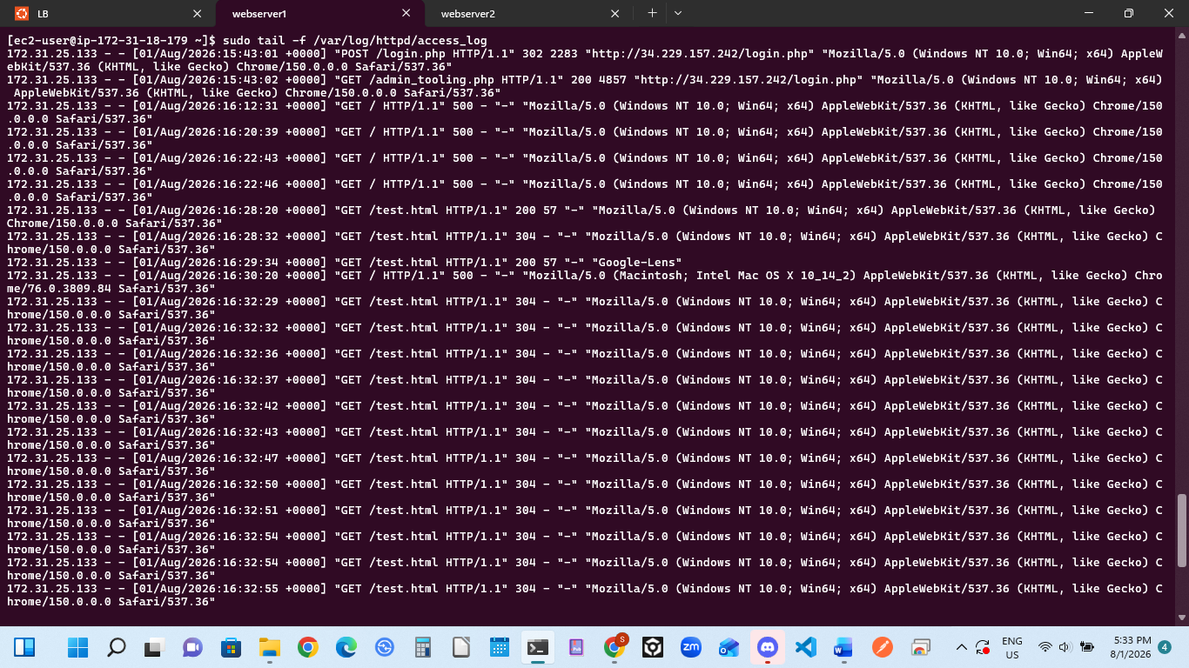

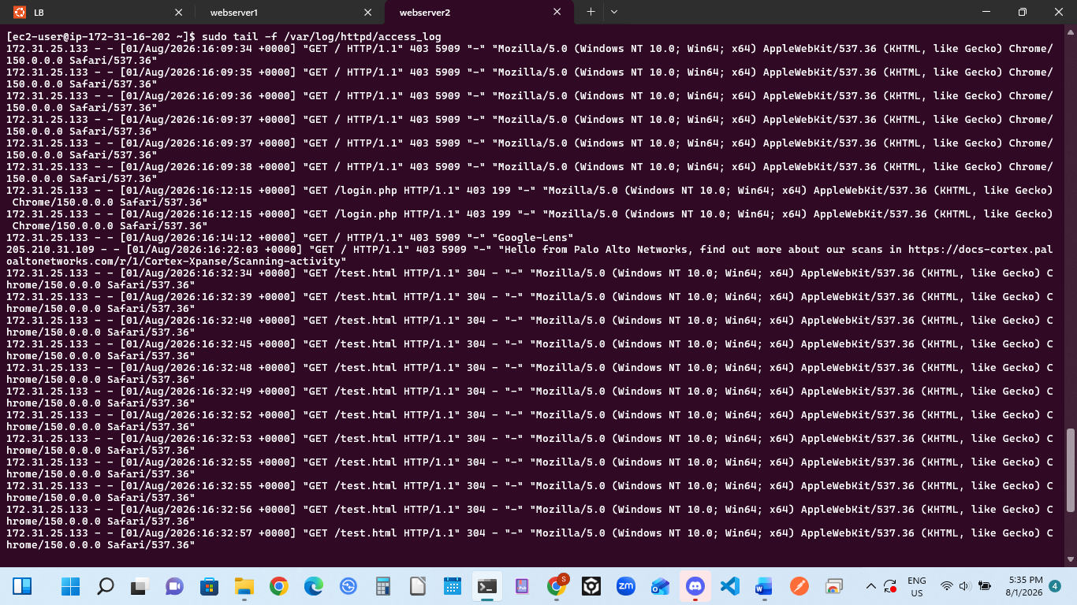

DESCRIPTION FOR MARKDOWN DOCUMENTATION

### Load Balancing Verification and Traffic Distribution Analysis

To validate that the Ubuntu Apache Load Balancer successfully routes and distributes traffic evenly across the backend cluster, a static test file (`test.html`) was deployed to the shared NFS mount point (`/var/www/html`). This bypassed database dependencies and allowed clean network verification.

Using the `tail -f /var/log/httpd/access_log` command on both Web Server 1 and Web Server 2, traffic patterns were observed in real time while making sequential browser requests to the Load Balancer IP (`34.229.157.242`).

#### Observations:
1. **Even Distribution:** Inbound HTTP GET requests for `/test.html` alternated sequentially between the two web server instances.
2. **Stateless Efficiency:** Because the load balancing method was configured as `lbmethod=byrequests`, each individual browser refresh was cleanly captured by a different node.
3. **Local Logging:** Both servers logged these operations to their respective local NVMe filesystems rather than overloading the NFS share, ensuring maximum operational performance.

The attached screenshot confirms successful Layer 7 content routing, a healthy response code of 200 OK across both nodes, and active load distribution in real time.

DIAGRAM
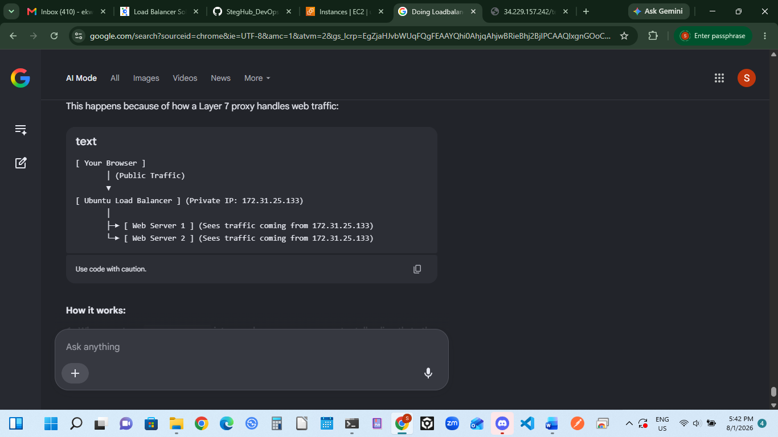

How it works:
- When user type 34.229.157.242 into your browser, the computer talks directly to the Ubuntu Load Balancer.
- The Load Balancer terminates that connection, looks at its routing rules, and opens a brand new internal connection to one of the RHEL web servers.
- Because the Load Balancer is the one opening the connection inside your AWS private network, Web Server 1 and Web Server 2 do not see the personal home computer's IP address. They only see the IP address of the machine knocking on their door: the Ubuntu Load Balancer (172.31.25.133).

### Technical Note: Testing Strategy under AWS Resource Constraints (no more than four servers running simultaneously allowed – 1xLB, 2xWebservers, 1xDB, 1xNFS)


To optimize AWS resource allocation and adhere to strict laboratory usage boundaries, the dedicated Database (DB) instance was systematically powered down prior to final load balancing verification. Because the primary objective of Project 8 is to validate Layer 7 traffic distribution, an ad-hoc health-check file (`test.html`) was deployed directly to the shared NFS mount point (`/var/www/html`). This decoupled the web tier testing from database availability.

Using this static file ensured that:
1. Both backend RHEL web servers could serve incoming HTTP requests with a successful '200 OK' status without relying on an active database socket connection.
2. The Ubuntu Apache Load Balancer could accurately monitor backend target health and distribute client traffic evenly across both web worker nodes.

